# Scenario #3

## Scenario Description

* When a player cannot reach betting limit. Even when a placing bet would only take a player to their betting limit, the bet cannot be placed.
* For example, if the player bets $100 with a balance of $150 and a limit of $50, the bet will not go through.

## Version Control

|  |  |  |  |
| --- | --- | --- | --- |
| Version # | Date | Author | Description |
| 0.1 | 18/10/2019 | James Bell | Initial Draft |
| 1.0 | 18/10/2019 | James Bell | Initial Version |

## Test Scripts

The following scripts will cover this scenario:

* 1.1 Test Script #1
* 1.2 Test Script #2

## Test Components/Requirements

This test scenario covers the following high-level test requirements (see scripts below for specific requirements covered by each test script):

* Component 1
* Component 2
* Functional Requirements Group 1

## Script #1

### Script Description

* Launch program and play interactively with any balance, bet limit and select any dice picture. The user must bet an amount that will take them exactly to their limit. Once selected the game displays that you cannot make the bet as it will take you below limit.

### Testing Requirements

This test script covers the following specific testing requirements:

* Any balance and bet limit.
* Must bet an amount that takes balance to exactly the same as the bet limit if lost.
* Any dice picture selected (e.g. Fish, prawn, rooster, crab, courd or stag)
* Must loss the roll and have wrong dice picture from the 3 dices.

### Setup

* Must be playing either play interactively.
* Must have a balance, bet limit and bet amount higher than 0.
* Must aim to have a bet that takes them exactly to the bet limit for their balance if lost.

### Teardown

* List all steps that should be taken after the test case is executed

### Script Steps

| **Step #** | **Test Action** | **Expected Results** | **Pass/ Fail** |
| --- | --- | --- | --- |
| 1 | Launch program | Launches successfully | pass |
| 2 | Select p (play interactively) | Askes for player name | pass |
| 3 | Input player name | Askes for initial balance | pass |
| 4 | Input initial balance | Askes for bet limit | pass |
| 5 | Input bet limit | Displays user info and askes for standard bet | pass |
| 6 | Input standard bet | Askes for symbol | pass |
| 7 | Input symbol | Displays selected and askes bet | pass |
| 8 | Input bet to take their balance to the bet limit if lost. | Displays cannot bet amount and askes for new bet amount | fail |
| 9 | End test | End test |  |

### Test Execution

|  |  |  |  |  |
| --- | --- | --- | --- | --- |
| Date/Time | Tester | Test ID | Test Phase | Status |
| 17/10/19 10:00am | James Bell | James1 | System Cycle 1 | Passed |
| 17/10/19 10:05am | James Bell | James1 | System Cycle 2 | Passed |
| 17/10/19 10:10am | James Bell | James1 | System Cycle 3 | Passed |
| 17/10/19 10:15am | James Bell | James1 | System Cycle 4 | Passed |
| 17/10/19 10:20am | James Bell | James1 | System Cycle 5 | Passed |

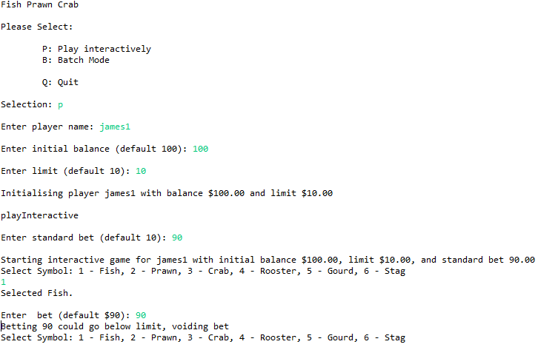Note: All failed attempts in test executions where when the program bet was won not allowing the bug to be seen. All passes where when the program bet was lost, and the bug was seen.

System Cycle 3